
Pre-School Breakfast Menu
June 2nd-11th

Monday, June 2nd
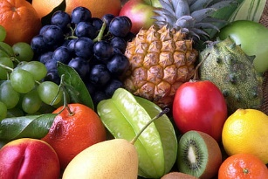
Chocolate Chip French Toast
Tuesday, June 3rd
Blueberry Waffles
Wednesday, June 4th
Assorted Muffins
Thursday, June 5th
Cinnamon Filled Bagels
Friday, June 6th
Cheese Stick & Assorted Crackers/Granola

Monday, June 9th
Strawberry Pancakes
Tuesday and Wednesday, June 10th and 11th
Chef’s Choice

All breakfasts are served with fruit and milk

Have a great summer 2025!

